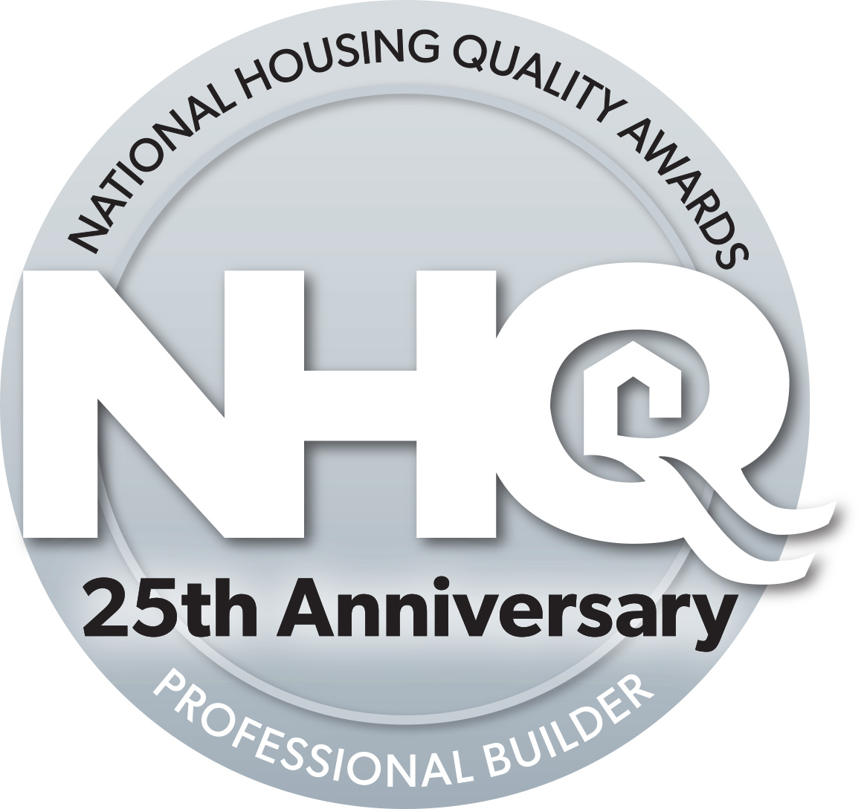
Intent to apply
APPLICANT INFORMATION
Please send this form to: Serge@potomack.net

Due to an increase in the time it takes for the judges to conduct both a desktop review and conduct appropriate site visits we are making some changes to the NHQ Award procedures. we are going to limit the number of applications we review to 12. Effective this year the application process incorporates two steps:

Step 1. Fill out and send this intent to apply form: by March 1, 2017 to the above e-mail and a hard copy with the application fee to:
Denise Dersin
Professional Builder Magazine
3030 W. Salt Creek Lane, suite 201
Arlington Heights, IL 60005-5025

Step 2. The application is Due April 10, 2017 (See application instructions)

Company Name:

President / CEO: e-mail:
Phone : (o) (c)

Address:

City: State: Zip:

Application contact:
Title:
Phone (O) (C)
e-mail :

Initial and date: / /

APPLICATION FEES Applying for a Division:
(Check appropriate lines ) For entire company:
25 or fewer homes $1,250.00
26 - 100 homes $1,750.00
101 + homes $2,000.00

To help defer the judges expenses, an additional fee of $ 1,000.00 will be charged to companies receiving a site visit.

For multiple sites an additional fee of $750.00, per site. or for travel to Hawaii, Alaska, Mexico or Canada.

Any previous applicant (within 3 years), aside from Gold winners, receive a 20% discount on all fees.

Agreement

I understand that members of an impartial examining team chosen to evaluate the NHQ Awards applications will review this application. Should our company be selected as a finalist, we agree to welcome the site visit team of examiners and facilitate an open examination of what we do to support what we have described in the attached application.
If the company is selected as the winner of an award, we will not publicly announce this award until we have been given authorization by the Award committee, and to abide by the rules of the Award. We also understand that this Award recognizes quality management excellence and is not to be viewed as an endorsement of certification of any product, or as an endorsement of your company by Professional Builder magazine or any of the examiners or sponsors of the NHQ Award.

Signature of Authorized Official:

Signature: Date: / / _

Name Title

